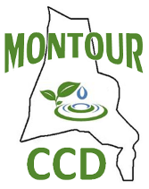
MEETING AGENDA
Montour County Conservation District Board
April 17, 2024 at 1:00 PM

Call Meeting to Order 1:00 PM

Public Comment Period

Welcome new board member Commissioner Scott Lynn

Approval of March Minutes pgs. 2-4

Approval of Treasury Report March-April pg. 5-6
Approval of Bills to be Paid

Credit Card Statements pgs. 7-12

Old Business

New Business
- New invoice to add to budget Viola Sewage Bill 731.40 per year

Other Reports
NRCS pgs. 8-9
Rachel Fish - DEP pgs. 10-18
E&S/NPDES/GP Report pg. 19
Staff Reports
Sean Levan pgs. 20-22
Tyler Servose pgs. 23-26
Claudia Eldred pg. 27-29
Quinn Hartung pg. 30-32

